EXERCISE 1
- CREATE DATABASE addressbook;
- DESCRIBE table_name;
- SHOW databases;
- INSERT INTO employee_data (f_name, l_name, title, age, yos, salary, perks, email)
VALUES ('Rudolf', 'Reindeer', 'Busines Analyst', 34, 2, 95000, 17000, 'rudolf@bugnet.com');
- 2 Forms to list all data in employee_data table
- SELECT * FROM employee_data;
- SELECT f_name, l_name, title, age, yos, salary, perks, email FROM employee_data;
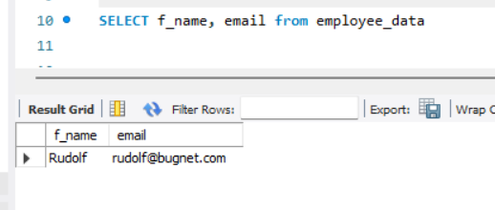

- SELECT salary, perks, yos FROM employee_data;
- SELECT COUNT(*) FROM table_name;
